
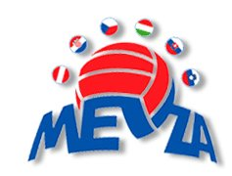
2015 MEVZA BEACH VOLLEYBALL U18/20 CHAMPIONSHIPS REGISTRATION FORM

The National Federation of

herewith registers the following team(s) for the 2015 MEVZA U20 & U18 Beach Volleyball Championships:

2014 MEVZA U20 Championships, Brno (CZE) – Deadline for registration 30.06.2015

 | Shirt # | FIVB # | Last name | First name
MEN | 1
MEN | 2
WOMEN | 1
WOMEN | 2
Head of Delegation

2014 MEVZA U18 Championships, Brno (CZE) – Deadline for registration 30.06.2015

 | Shirt # | FIVB # | Last name | First name
MEN | 1
MEN | 2
WOMEN | 1
WOMEN | 2
Head of Delegation

Name of the President and/or Secretary General (printed)

Signature of the President and/or Secretary General

Seal of the National Federation

Date and Venue

This form must reach the Czech Volleyball Organization (matejkova@cvf.cz and bauerova@cvf.cz) AND MEVZA (mel@mevza.org) duly completed prior to the deadline set for the event. Late requests will not be considered.

© MEVZA 2015

